Exercise 6

1. Use a one-dimensional array to solve the following problem: A company pays its salespeople on a commission basis. The salespeople receive $200 per week plus 9 percent of their gross sales for that week. For example, a salesperson who grosses $5000 in sales in a week receives $200 plus 9 percent of $5000, or a total of $650. Write a script (using an array of counters) that obtains the gross sales for each employee through an HTML form and determines how many of the salespeople earned salaries in each of the following ranges (assume that each salesperson’s salary is truncated to an integer amount):

a) $200–299

b) $300–399

c) $400–499

d) $500–599

e) $600–699

f) $700–799

g) $800–899

h) $900–999

i) $1000 and over

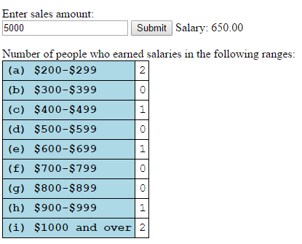

* You should show the salary based on the sales amount.
* The distribution of salaries is shown in a HTML table.
* The distribution of salaries is changed after submitting a new record of sales amount.
* Please apply the external CSS file: style.css.
* You can copy the text from the file: table-example.txt.

1. Please develop a webpage to show all 7 photos of CPBL (中華職棒) stars ("陳金鋒","胡金龍","林益全","高國輝","彭政閔","林智勝","鄭凱文") in random orders and random coordinates (both X and Y are smaller than 400px).



Hint:

* You should declare three arrays to store the file names, x-coordinates, and y-coordinates.
* You should shuffle the file names by swapping array elements randomly.
* You should decide x-coordinates and y-coordinates randomly.
* You can use the following CSS rules to display the photos:

*position: absolute; top: ?px; left: ?px;*